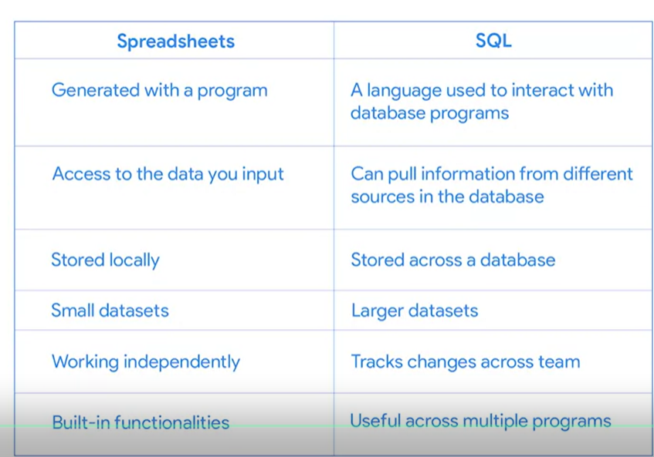

CAST() can be used to convert anything from one data type to another

CONCAT() adds strings together to create new text strings that can be used as unique keys

COLESCE() can be used to return non-null values in a list

**Terms and definitions for Course 4, Module 3**

**CAST:** A SQL function that converts data from one datatype to another

**COALESCE:** A SQL function that returns non-null values in a list

**CONCAT:** A SQL function that adds strings together to create new text strings that can be used as unique keys

**DISTINCT:** A keyword that is added to a SQL SELECT statement to retrieve only non-duplicate entries

**Float:** A number that contains a decimal

**Substring:** A subset of a text string

**Typecasting:** Converting data from one type to another